Module 3

- For Loop in C | HackerRank

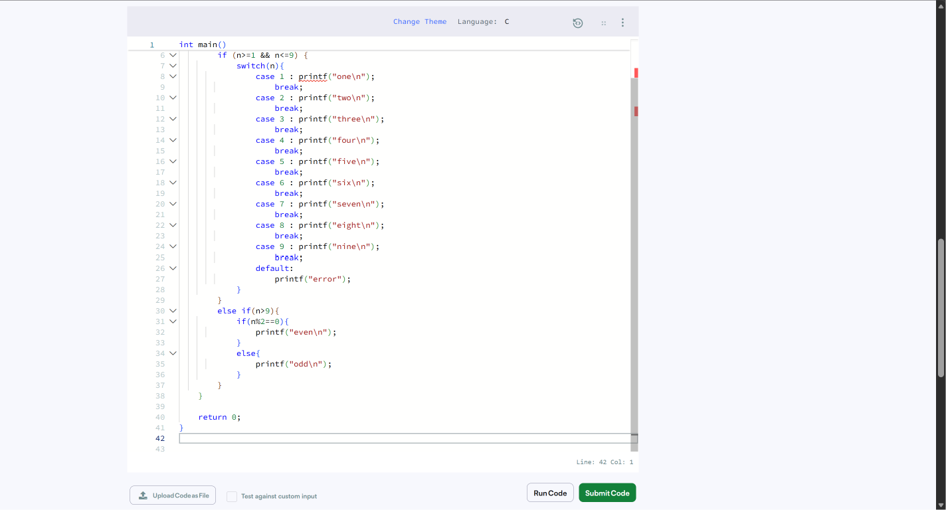

- Number of Steps to Reduce a Number to Zero - LeetCode
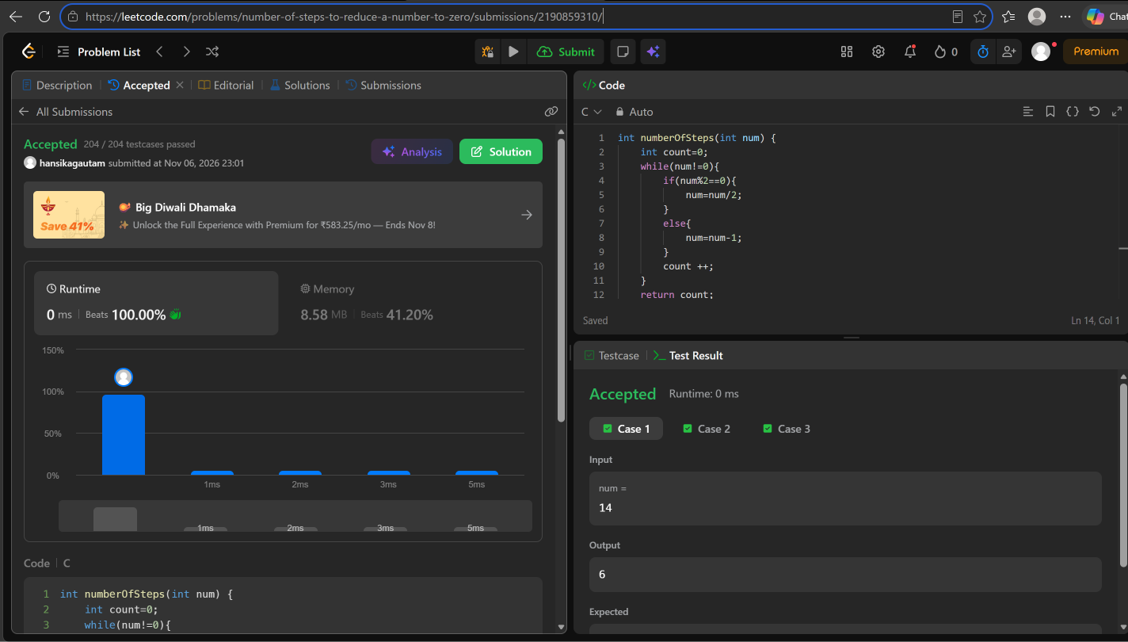

- Count Operations to Obtain Zero - LeetCode
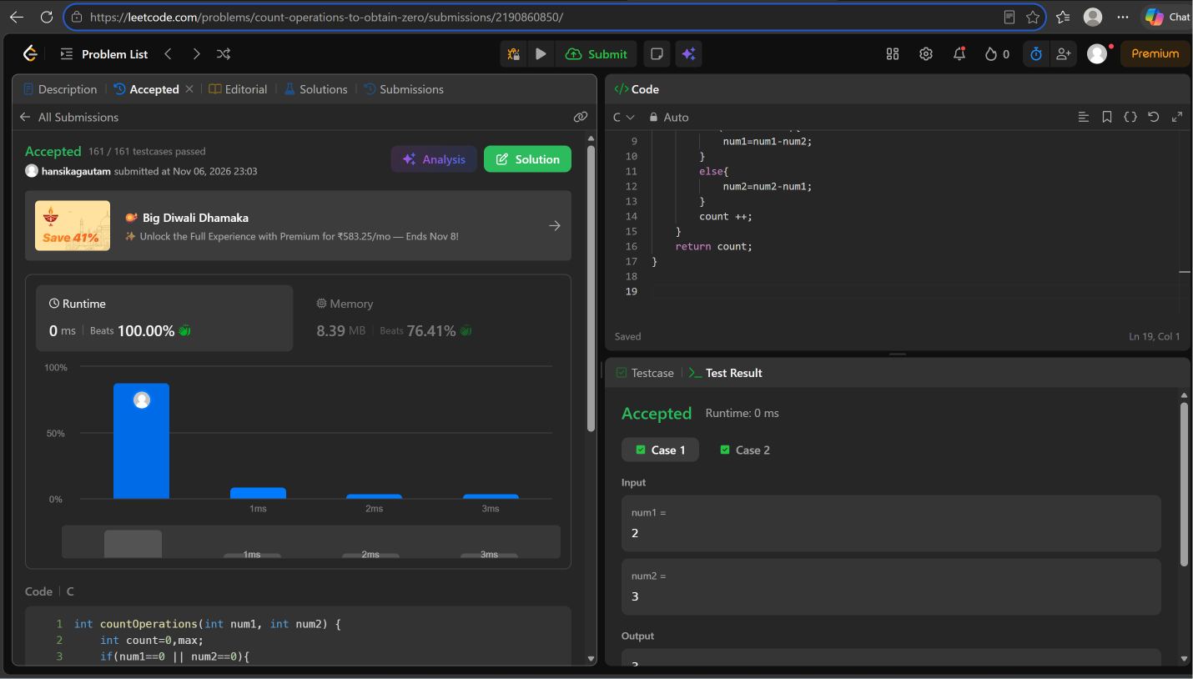

4. Count Odd Numbers in an Interval Range - LeetCode
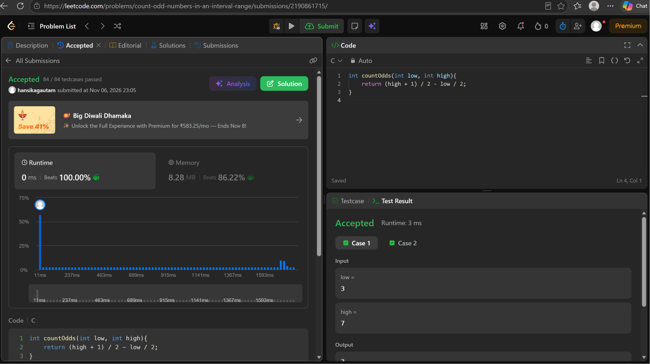

5 . Sum Multiples - LeetCode
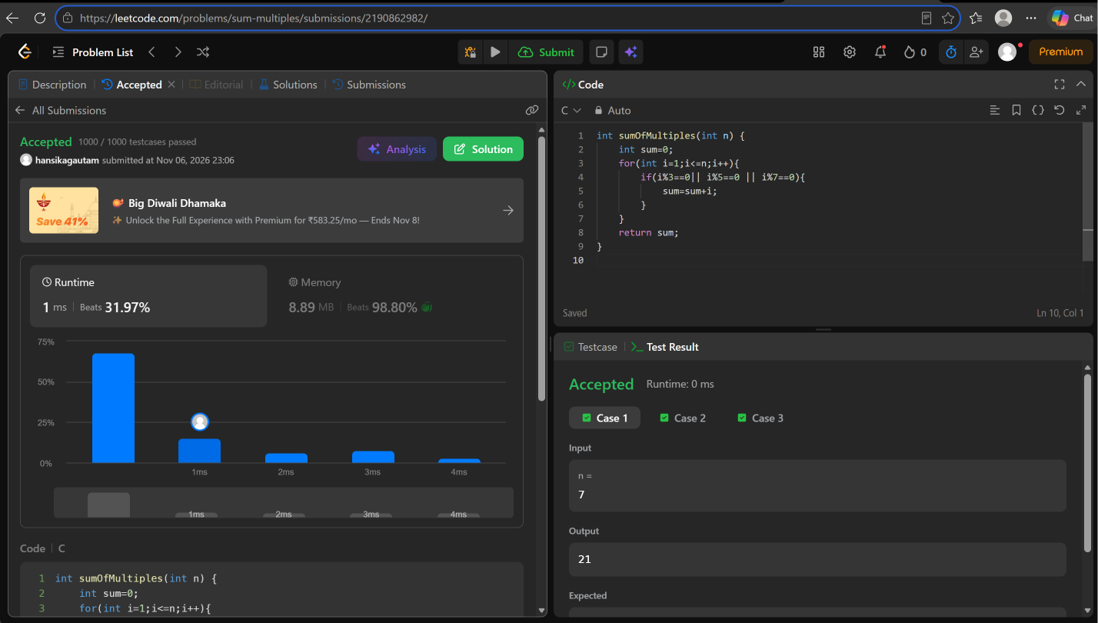

6. Number Line Jumps | HackerRank



